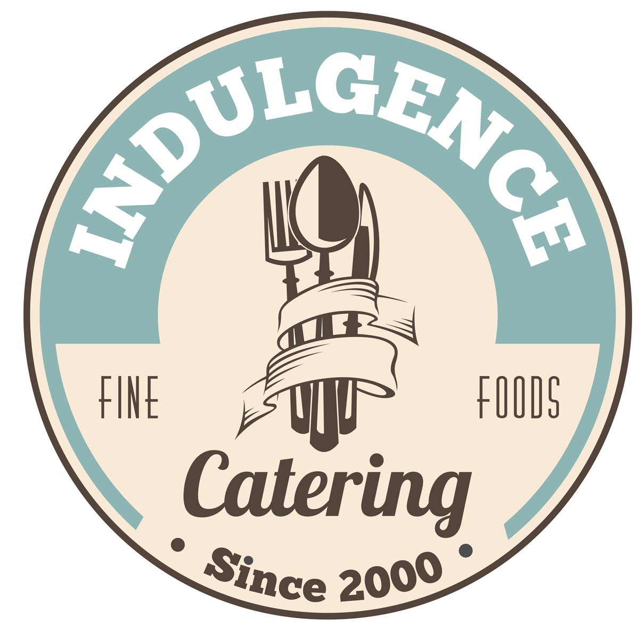

At

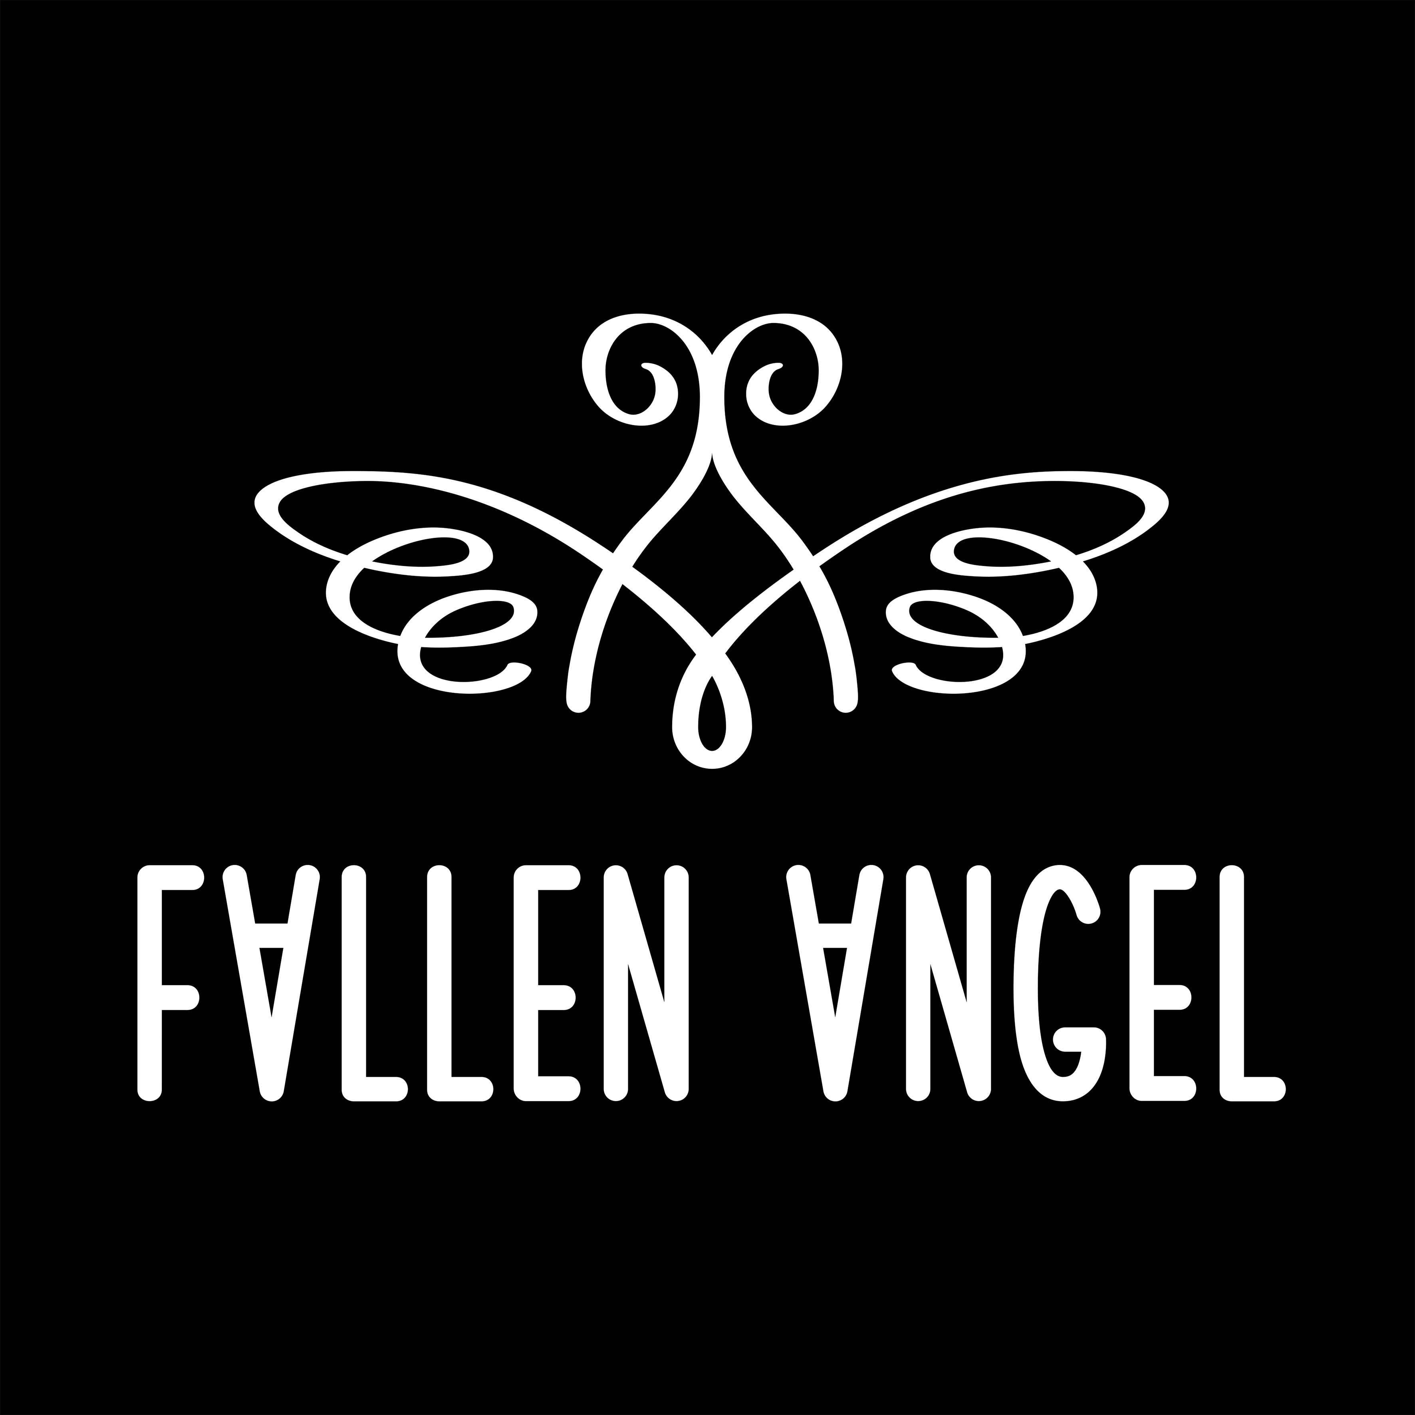

Breakfast for 2
For large appetites or two days

£60

Rebecca Farrington 07779998590
info@indulgence-catering.co.uk

Order ahead of your stay and have this waiting in Fallen Angel for you on arrival.

Indulgence Homemade granola
Chy Praze Farm Sausages
Chy Praze Farm smoked bacon
Cornish hogs pudding
Half dozen local free-range eggs
Baker Toms loaf of bread
Trewidden Dairy butter
Indulgence homemade strawberry jam
Indulgence homemade tomato sauce
Polgoon apple juice
Tregothnan tea
Cornish coffee
Trewidden Dairy milk

